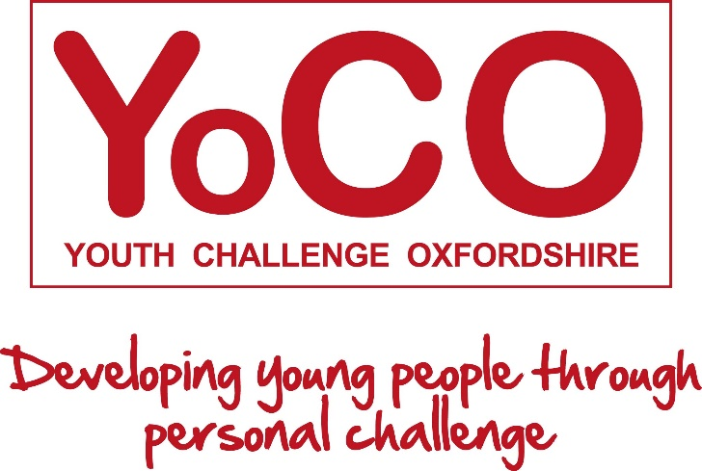
Buttercup Challenge 2021 - Sponsorship
Dear xx

I’m taking part in The Buttercup Challenge on the 22/23 May 2021 in aid of YoCO - Youth Challenge Oxfordshire, an excellent Oxfordshire based charity which helps to develop young, and sometimes vulnerable, people through personal challenge.
The target is to help raise £5,000 by completing a Challenge involving 5,000 active “anythings", eg running, swimming, cycling 5km or skipping 5,000 times or walking the dog for 5,000 seconds (that’s 1h23m!). l’ve chosen to do………
Please will you support me in my Challenge by making a donation to YoCO. It’s really easy to donate; simply go to Virgin Money Giving and give as much as you can, no amount is too small! Please remember to mention my name when you donate.
Excitingly The Mosawi Foundation, a YoCO supporter, has offered to ‘match fund’ every £1 raised up to £5,000 so the potential to make a real difference to YoCO is huge. You can read more about The Buttercup Challenge at buttercupchallenge.com and learn more about the work of YoCO at www.yoco.online.
Thank you for your support - it means a lot to me and the young people at YoCO!
Best wishes
xxx

